MLA STYLE FOR RESEARCH PAPERS
Based on Current MLA Standards (Sixth Edition, 2003)

Be sure and check with your teacher to see if you should be using this standard format.
Some teachers make changes that you will need to take into consideration. Always check!

Basic Paper Format
-Y | General Guidelines | Hints When Using Microsoft Word
 | Type your paper using a standard 12 pt font such as  Times New Roman or Arial. | Go to Format � Font
 | Use 1” margins on all sides of your paper (top, bottom,  left, and right). | Go to File � Page Setup
 | Double-space your entire paper. Do not use single  spacing or add extra spaces between lines or paragraphs, unless instructed to by your teacher. | Go to Format � Paragraph and change the Line  Spacing to Double
 | Create a running header in the upper right-hand corner of  each page, ½” from the top, with your last name and the page number. | Go to View � Header and Footer, select right align,  type your last name followed by a space, and then click on Insert Page Number
 | Always proofread and spell check your work. | Go to Tools � Spelling and Grammar…
 | Always "Preview” your report before printing. | Go to File � Print Preview

Formatting the First Page of Your Paper
-Y | First Page Guidelines
 | Do not make a title page unless your teacher requests one, and then follow the format specified by your teacher.
Header: In the top left corner of the first page, 1” from the top, list each of the following items on a separate line: your
name, your teacher’s name, your class, and the date (use the European date month year format).
 | Center the title on the next line below the header—do not underline, capitalize, or put it in quotation marks.
Begin your paper on the next line below the title. Make sure to indent the first line of each new paragraph by ½” using
the Tab key.

(Sample first page)
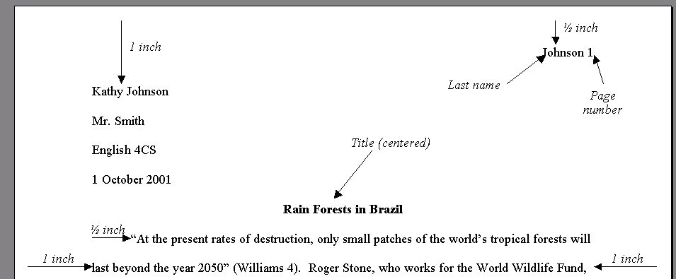

(Sample second page)
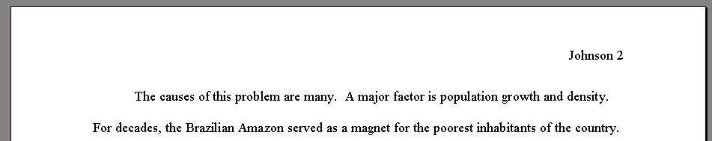

Formatting the Works Cited Page
It is necessary to give credit to any source(s) that you have used when presenting information such as in a speech, a
research paper, or a poster—plagiarism is an offense and can cost you credit! Therefore, with each paper you write, you will need to prepare a list of Works Cited (or a bibliography). This is the only place where a reader can locate complete information about the sources cited in your paper, and for this reason, you must be thorough and accurate.

-Y | Works Cited Page Formatting Guidelines
 | Begin your works cited list on a new page after the body of the essay.
 | Like the rest of your essay, double space your entire Works Cited page.
 | Center the title, Works Cited (with no quotation marks or underlining), 1” from the top of the page.
 | Start your first entry on the next line under your title. Do not add extra spaces after the title or between entries.
Use hanging indentation—begin the first line of each entry all the way to the left of the page, and if the entry is longer
than than one line, indent each subsequent line of the entry by ½” using the Tab key.
List entries in alphabetical order by the first word in each entry (usually the last name of the author). NOTE: When
alphabetizing by book or article titles, do not count A, An, or The as the first word of a title (e.g. you would write out "The
Real Vaquero" like this, but alphabetize it under R for Real).

(Sample Works Cited Page)
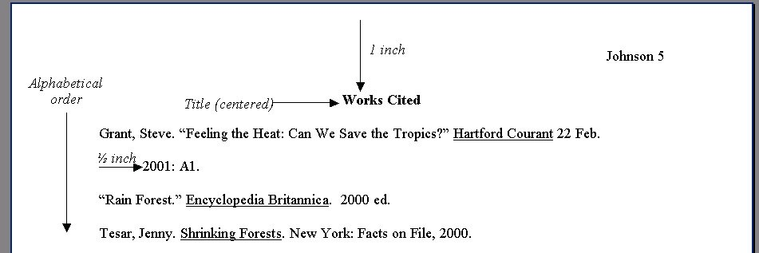

Formatting Works Cited Entries
Once you have located a useful source such as a book or article, record all necessary information about the source using the proper MLA format. Use the examples on the pages that follow as a guide.

-Y | Works Cited Entries Formatting Guidelines
 | Sources may vary in the publication information provided. In other words, not all sources will have every piece of information that you are looking for. If you are unable to locate some information on a source, just cite what is available.
 | Check your punctuation and spacing against the examples—look out for all periods, commas, and colons.
 | Use the inverted form of an author’s name (Last Name, First Name) when it is the first part of an entry.
Underline (or place in italics) all titles of larger works such as books, periodicals and films. Underlining and italics are
equivalent; choose one style and use it consistently throughout your paper.
Use quotation marks to indicate "titles of shorter works" that appear in larger works, for example, a "magazine article"
from a magazine or a "poem" from a book of poetry.
If more than one city of publication is given, list only the first. For cities outside the United States, add a country
abbreviation.
When possible, use the shortened form of the publisher's name - Random instead of Random House or Random
House, Inc.
Use the European format for date listing—giving the date, month and year in the form: 2 Oct. 1999. Use three-letter
abbreviations of the months (e.g. Jan., Feb., Mar.)
 | Do not use “p.” or other page notation, as numbers are just understood to be page numbers.
For Internet URL addresses, use the complete address (for example, starting with http) enclosed in angle brackets < and
>. If a URL is long and takes up more than one line, break it only after a slash.

: PLEASE NOTE: While this handout includes examples of how to cite the most common types of sources, it is not an exhaustive list. Keep in mind that there are specific formats for all different types of sources from translated books and multivolume works to editorials and reviews. To find the format for sources not included in this handout, refer to the MLA
Handbook for W riters of Research Papers, 6th ed. or online guides such as the Purdue University Online Writing Lab website: <http://owl.purdue.edu/handouts/research/r_mla.html>.

Books:

Author’s Name(s). Title of Book. City of
Publication: Publisher, Year of Publication.
Articles in Periodicals:

Author’s Name(s). “Title of Article.” Title of
Periodical Date: Page Number(s).

Examples:

A) Books with a Single Author
Examples:

H) Magazine Article, Signed and Unsigned

Marrin, Albert. Aztecs and Spaniards. New York: Antheneum, 1986.

B) Books with Two or More Authors – List names in the order they appear on the title page. Invert only the name of the first author.

Cargill, Oscar, William Charval, and Donald Walsh.
The Importance of Clear W riting. New York: Harcourt, 1999.
C) Book with an Editor – Follow the name with ", ed.". Hall, Donald, ed. American Literary Criticism. New
York: Oxford UP, 1998.

D) Books with No Author or Editor Given – Start the entry with the title of the book. When alphabetizing the entry, ignore any initial A, An, or The. For in-text citations, use a shortened version of the title.

Encyclopedia of Photography. New York: Crown, 1988.

Pieces or Articles in Books:

Author’s Name(s). “Title of Piece or Article.” Title of Book. Ed. Editor. City of Publication: Publisher, Year of Publication. Page Number(s).

Examples:

E) Work (e.g. Essay or Poem) in an Anthology

Lazard, Naomi. "In Answer to your Query." The Norton
Book of Light Verse. Ed. Russell Baker. New
York: Norton, 1986. 52-53.

F) Occupational Guidance

“Dog Trainer.” Occupational Guidance. Vol. 1 Unit 5.
Minneapolis: Finney, 1998.

G) Encyclopedia Article, Signed and Unsigned – For major encyclopedias (i.e. World Book, Britannica, and Encyclopedia Americana), you may leave off the editor, volume and page numbers. For publication information, simply list the edition and year of publication.

Crutzen, Paul. "Ozone." Encyclopedia
Americana. 1998 ed.
"New York Stock Exchange." Encyclopedia Americana.
1998 ed.
Mannix, Margaret. "Avoid These Card Tricks." Reader's Digest Oct. 1999: 118-121.
"Young, Rich and Miserable." Newsweek 27 Sep.
1999: 10.

I) Newspaper Article, Signed and Unsigned – Give the section and page number, if known.

Simison, Robert. "Making Digital Decisions." W all
Street Journal 24 Sep. 1999: B1+.
"Stronger Lemon Law Signed." San Diego Union 24
Sep. 1999: A3.

Miscellaneous Sources:

For exact guidelines on these miscellaneous sources and any other sources not included in this handout, refer to the MLA Handbook for W riters of Research Papers, 6th ed. or the Purdue University Online Writing Lab website:
<http://owl.purdue.edu/handouts/research/r_mla.html>.

Examples:

J) Speech

O’Connor, Sandra Day. Commencement Speech.
Colorado College, Colorado Springs. 24 May
1998.

K) Class Lecture

Howard, Pam. Lecture. El Capitan High School, Lakeside. 23 Sept. 2003.

L) Personal Interview (that you conducted)

Clinton, Hillary. Personal interview. 12 September
1999.

M) Television or Radio Program

“The First Americans.” NBC News Special. By Craig
Fisher. Narr. Hugh Downs. KNSD, San Diego. 21
March 1998.

N) Music CD

Springsteen, Bruce. The River. Columbia, 1982.

O) Videocassette or DVD

Alzheimer's Disease. Videocassette. American
Institute of Nursing, 1995

Citing Electronic Resources
Below are simplified formats for citing some common electronic resources. Citations should include as many of the following items as possible. If you cannot find some of the information, just cite what is available.

General Web Sites:

Author’s Name(s). “Title of Document or Article.” Title of Internet Site. Date of Electronic Publication or Last Revision. Date Material Accessed <URL of Source>.

Examples:

"Endangered Species Act Upheld." AP Online. 22
June 1998. 22 June 1998
<http://www.nytimes.com/aponline/w/ AP-Court-Endangered-Species.html>.
El Capitan High School Library. 5 Sept. 2004
<http://eportal.guhsd.net/snegoro/library/
index.htm>.

E-Mail:

Sender’s Name. “Title of Message from Subject Line.” Email to Recipient’s Name. Date of Message.

Example:

Boyd, Lyndon. "Computer Virus Issues." Email to
Howard Blakely. 5 May 2004.

Library Subscription Sources:

Author’s Name(s). “Title of Document or Article.” Title of Print Magazine or Book Print Version Publication Information. Name of Subscription Service. Name of Subscriber, City, State Abbreviation of Subscriber. Date Material Accessed <URL of Subscription Service>.

Example:

Clayton, Mark. “Earth Day’s Biggest Challenge Yet.” Christian Science Monitor 22 April 2004.
Electric Library. El Capitan High School, Lakeside, CA. 8 July 2004 <http://elibrary.bigchalk.com/ libweb/elib/ do/ search>.

Online Postings:

Author’s Name. “Title of Posting from Subject Line.” Online posting. Date of Posting. Name of Forum. Date of Access <URL of list’s Internet site>.

Example:

Lavagnino, John. “OCR and Handwriting.” Online posting. 7 May 2002. Humanist Discussion Group.
24 May 2002 <http://lists.village.virginia.edu/
lists_archive/Humanist/v16/0001.html>.

Citing Sources in Text
As you write your research paper, you will select information to include from your various sources. Whenever you “borrow” from your sources, you must give them proper credit. You must provide documentation if you 1) use a quotation, text that is quoted word for word and enclosed in quotation marks; 2) include an idea or theory that belongs to someone else, even if you write about it in your own words; or 3) refer to a specific fact, statistic, or detail, again, even if you write about it in your own words. The way that you give credit to your sources is by using parenthetical documentation. Below are some general guidelines on and examples of how to cite sources in your essay using parenthetical documentation.

� Give credit to a source at the end of a sentence, but before the period. List the author’s last name and relevant page number(s) in parenthesis. Separate the name and page numbers with a space and no comma.
� Remember that there is no "p." or other page notation, as numbers are just understood to be page numbers.
� If you are providing citation for a quotation, place the parenthetical documentation after the last quotation mark, but
before the final period.
� If there is no author provided, use instead the first word of the title, excluding A, An, or The.

Examples: “The introduction of the microcomputer to America’s high schools has greatly changed the way students view the research process” (Jones 12-13). School libraries on average have 1 computer for every 120 students (Wu and Li 7). Just ten years ago, the statistic was 1 for every 300 (Technology 37).

� As an alternative, you can use the author's name in a sentence and then place only the page number(s) in parenthesis.

Examples: Jones states that the "introduction of the microcomputer to America's high schools has greatly changed the way students view the research process" (12-13). In their research, Wu and Li found that school libraries on average have 1 computer for every 120 students (7). According to Technology in the Classroom, the statistic was 1 for every 300 just ten years ago (37).

: Exception: Longer quotations (4 lines or longer) are set off and thus do not require the use of quotation marks.
Starting on a new line, they are indented ten spaces from both margins. Parenthetical documentation for long quotations is included at the very end of the quotation, one space after the period.

